**934 DT  
Documentation  
HdM Cutter/Laser Plug-In**

Holger Rasch 02.07.2014

## Plug-In description

It was the goal to create a new Plugin for the HdM Cutter and Laser cutter with the following requirements:

1. Shorter cutting times due job optimizations
2. Forecast of the needed cutting time
3. Directly implemented in Rhino without any external tool

### Job Optimization

Without optimization of the path to cut, the cut order will be used in order of its creation. Especially for large jobs there could be a lot of empty tool traveling. To prevent this, we tested different algorithms to optimize the process order. We are using the so called Nearest-Neighborheuristic (NENE) followed by a 2-opt-heuristic. The NENE is a simple method of graph theory. Starting from the current position, the nearest neighbor is searched. The plug-in always considers the start point and the end point of an object. If necessary, the cutting direction is reversed (i.e., from end point to start point). The 2-opt heuristic is a de-crossing mechanism by turning the cut direction. Since both methods can be computationally very expensive, we applied - depending on the number of objects to be optimized - only the NENE or in the worst case no optimization, because an optimization calculation would take longer than the expected time savings. Can in principle lead to an NENE of any bad solution, together with the 2-opt-heuristic we never get a worse result than without optimization.

We tested also some other algorithm like the so called Farthest-Insertion and a simple Sort-by-X method. Both of them delivered only exceptional better results.

In the case that must comply the cutting direction with the drawn direction of the geometry you must omit the optimization.

### Cutting Time

At three different situations a time statement will be shown:

*Before Cutting*: During the creating of the job preview the estimated time will be displayed in the form h:mm. These values based on a simulation of the length of the cut, empty travel paths and the known speed of the tools. The precision is limited to incalculable factors like calibrating of the device during the cut or while the tool is changing.

*While cutting*: Based at the already cut length, the already elapsed time and the still to cut length the time of completion will be shown (like 16:22). After every cut object, the result will be updated. The precision will increase to the end of a job. Empirically you can trust the result after a quarter of the job is done. Imprecision can happen if at the beginning of the job a completely different kind of geometries are cut as at the end (like a bunch of circle at the beginning and at the end a lot of boxes).

*After Cutting*: When the job is done, the duration of the job will be displayed.

### Rhino Implementation

The plugin was deigned to work directly in Rhino with no other (external) tools. You will get a preview of the geometry which will be cut. You can set values for the cut job like cut speed etc. Finally the commands will be transmitted directly to the cutter. The cutter will be start without any further interaction. Inside Rhino you can follow the current job at the screen. The currently cut object will be highlighted at the screen and the remaining time will be displayed. It is still possible to prepare cut jobs, save them as plt-file and send them later to the cutter. These prepared file will be also shown on the screen after loading. A later change of the tool parameter is also possible.

All device depending parameters are defined outside of the plugin in some special configuration files. With these configuration files we are able to made later customizations, without any change on the program code.

## APPENDIX A

for pin board next to the cutter and   
as part of the handout documentation after the cutter introduction

## Preparation

### **Rhino 5 File**

Open your file with rhino 5. You can also import a .dwg with Rhino 5. The plug-in does not work with Rhino 4.

### **Scale/Units**

Modify the scale. The drawing has to be drawn in millimeters at a model scale 1:1.

If you draw a 100 mm line, the machine is going to cut 100 mm.

### **Layers**

Place what you want to cut to layers that you want. Please consider that you can assign each layer to only one tool. You can assign multiple layers to the same tool:

Layer 01 🡪 SP1

Layer 02 🡪 SP2

Layer 03 🡪 -

Layer 04 🡪 SP2

Layer 05 🡪 SP4

There is currently no way to control the cut order of the tools. The plug-in internal optimization will sort the geometry in an own manner. The tool order for the Zünd Cutter is: SP4, SP1 and at last SP2; for the Laser is: Engraving (ENG) and then Cutting (CUT)

### **Start the Plug-In**

If the Plug-In panel is not visible start the plug-In with the command *CNC_OpenPanel*. If Rhino regret this with a message like: “Unknown command: *CNC_OpenPanel*” please read the chapter “Plug-In Installation”.

### **Reference** Point

To set the reference point you have to select Tool 2 to be active. Tool 2 is a normal laser pointer with which you can set the reference point really precise. Therefore go into the menu, “tool”, “select tool”, “tool number” and “2” or push 2 -1 - 1 - 2.

Press the button on the machine with the two arrows going down and the red light of the laser pointer will be switched on. Set a new reference point by moving the laser to the position where you want it to be and push “REF”, then “1”.

After you set the reference point you have to select tool 1 to make sure that your file is going to be cut by the laser and not only be traced by the laser pointer. When you set the laser to be active again it will move to the position where you set your reference point before. It is always good to check the Reference point before cutting. In the “REF” option, press the command” go to REF”. If it is set correctly, it should to the cutting position.

## How to cut from a drawing

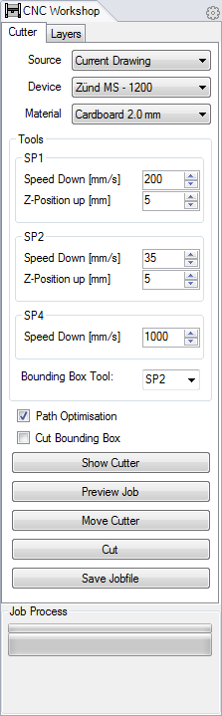

1. Make sure that you can see the whole plugin with all buttons like in the picture left.
2. 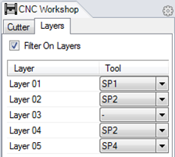Select a material to get the best settings for the tools
3. On the Layer Tab make the right assignment which layer will be cut with which tool.
4. Show the Cutter; so that you can:   
   (Switch the device online before to show the reference-point on the right position)
5. Move it to your geometry.
6. Cut!

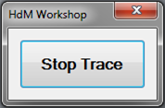  
  
While you cut, you will see inside Rhino which geometry is currently cut, how long it takes etc. As long as you are tracing the job progress, you can’t work with Rhino. You can stop the trace. This will **not** **stop** the cut or the job transmission to the cutter.   
**You cannot stop the cutter in Rhino.**

## APPENDIX B

as part of the handout documentation after the cutter introduction  
and even hanging as bound print-out next to the cutter

## Work with **the Plug-In**

The plugin contains two tabs. One with all settings related to the cutter device, and one with the layer tool assignment.  
  
**Cutter Tab:**

1. With the “Source” list you can select from where your geometries come that you want to cut. It can be the current drawing or a previously prepared plt-file. In the last case an “Open file” dialog appears to select a plt-file.
2. If you cut from the current drawing, you have to decide, on which cutter you want to cut. You can choose between “Zünd MS-1200 Cutter” and the “Eurolaser 800”. Once you loaded a plt file, you can’t change the device anymore.
3. From the Material list you can select some predefined material settings. These values are well approved, but you can change this of course.
4. In the “Tools” area you can change several tool settings like cutting speed, travel height and also the tool to cut a bounding box. This setting depending on the device of course.
5. With the path optimisation you can save a lot of cutting time. The plugin calculate a short path through your geometry without unnecessary empty traveling paths. Unfortunately this procedure is very computationally intensive. With more than 1500 objects the calculation process will take longer than the possible time saving. In this case the path optimization will be switched of automatically. You have the opportunity to switch it off.
6. You have the oportunity to cut a bounding box with an offset of 5 mm around your job. This is to save material because a well cut rest of material is easier to recycle. If your job is very big and the rest of your sheet is really useless you can switch off the bounding box. Per default this feature is disabled.
7. 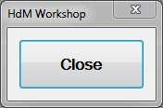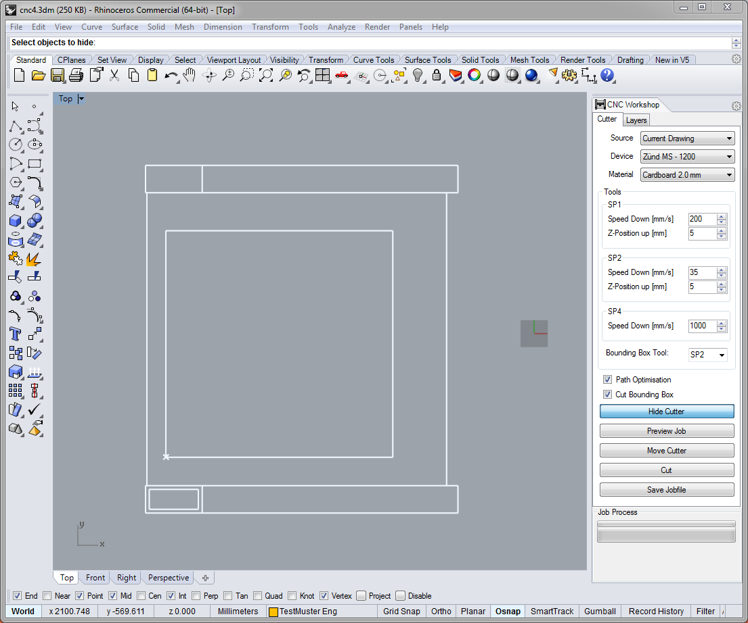Show Cutter – this will display the device in Rhino. The plugin tries to read the position of the Reference Point, this works only if you switch the device online before. If the device is offline, a small window appears until you switch the device online or click “Close” At the first time the cutter will be shown at 0,0,0 .
8. 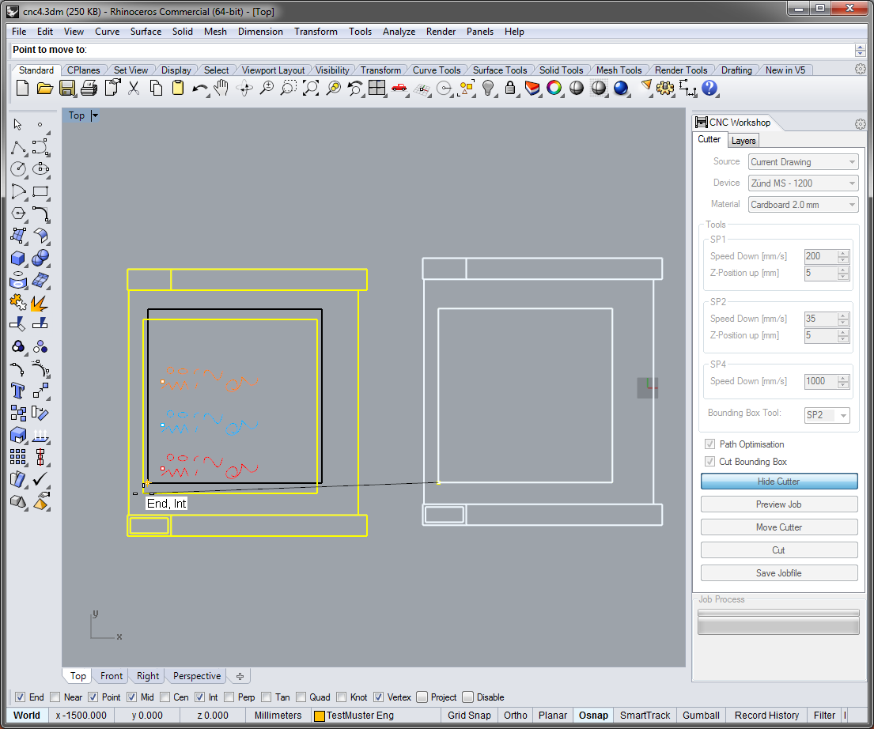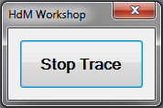If your geometry to cut is not located at 0,0 you can move the geometry to the device, or you move the device to the geometry with the “Move Cutter” button. A left click will start a move operation like in a standard rhino move operation. You have to choose from which point to which point do you want to move the cutter. You can only snap points at the cutable area. A right mouse click starts a move operation from the left bottom corner to a point. If you have loaded a plt-file, you can move the position of your job instead of the device.
9. 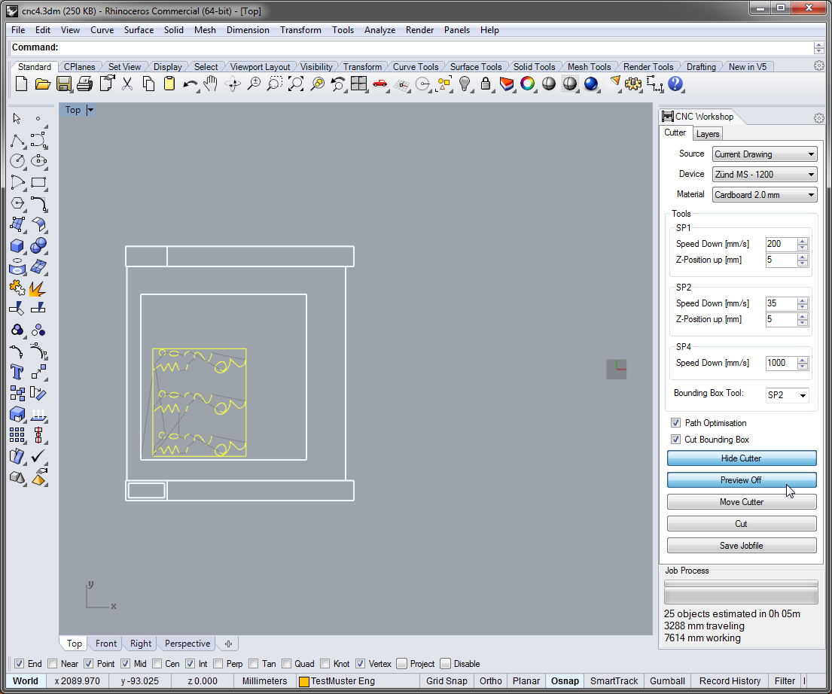With the “Preview Job” button you will see in yellow which objects will be cut. Gray lines indicate the non-cutting traveling of the tool. If nothing will be displayed, please check in the layer tab the right setting (see 16.). During the preview is on, all objects are invisible except the cutter geometry. In the bottom line of the plugin you can see the estimated time for the job.
10. 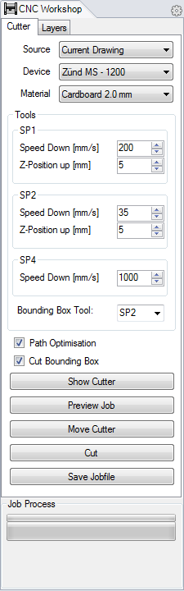If everything looks fine you can send the job direct to the device by clicking “Cut”. If you click with the left mouse button you will trace the job progress on the Rhino screen. A right mouse button click will send the job command directly without tracing.
11. “Save Jobfile” will write a plt-file for later use. A save file dialog will appear.
12. While the job command is sent to the cutter you can stop the transmission.
13. 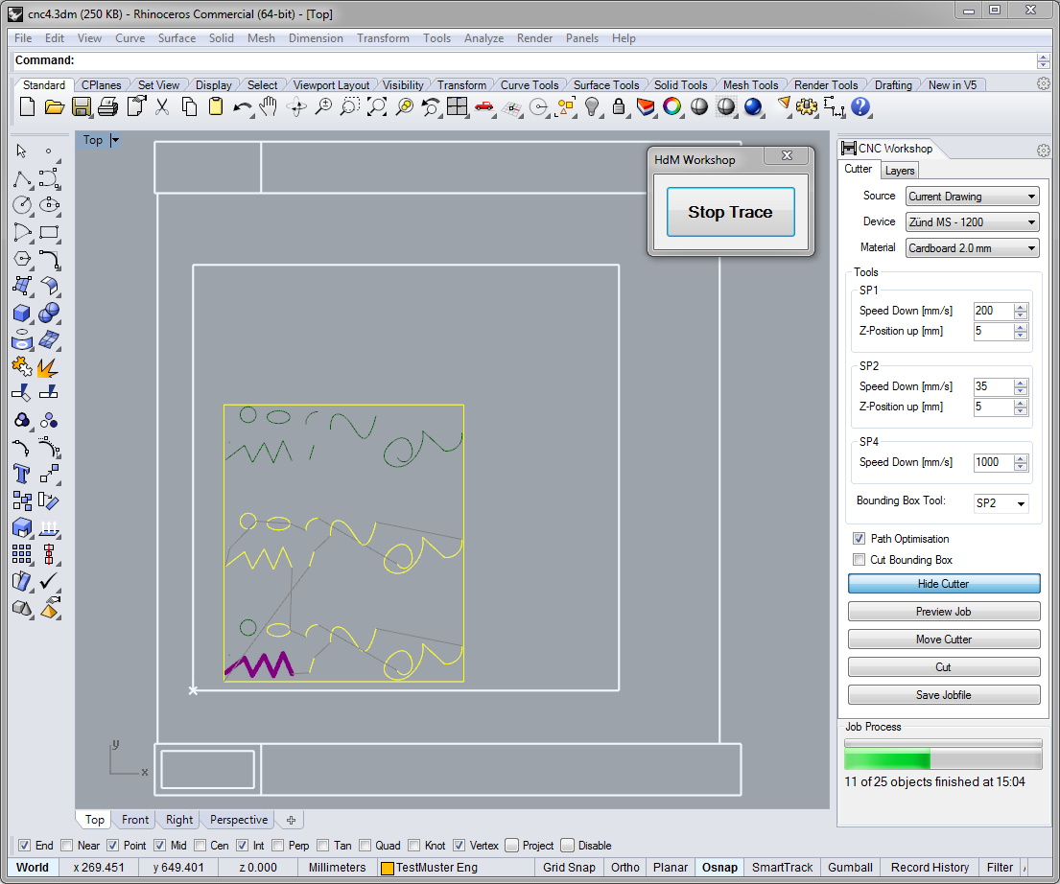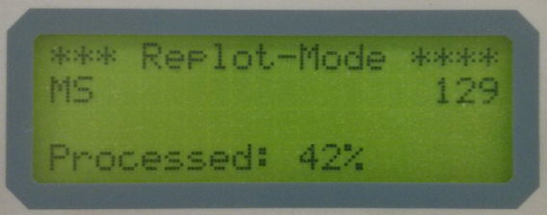During the cutting process you can see which object is currently cut (in purple) which object will be cut later (yellow) and which objects are already cut (green). In the bottom line of the plugin you can see the estimated finish time.  
    A progress-bar shows the current job progress and in the fourth line of cutter display you see the percent that has already been cut.
14. 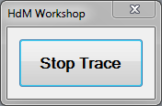If you do not want to follow the cutting progress in Rhino click “Stop Trace”. While tracing you cannot use Rhino. This will not stop the cutting process or the job transmission to the cutter.  
    **You cannot stop the cutting machine in rhino!**

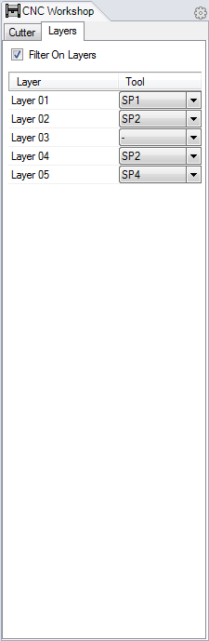**Layers Tab**

1. You can filter all visible layers
2. On the Layers tab you have to assign which layer is using which tool. This information will be stored in the drawing.

## Plug-In Installation

The plugin is already installed at the control computers next to the cutters.

If you want to work on your own computer or something is failed on the control computer try the following steps:

1. Close Rhino
2. Make sure that nobody else is logged into the computer.   
   If you’re not sure please restart the computer.
3. Open Rhino5
4. Drag & Drop the file "C:\HdM-Rhino5\RhinoCNC\RhinoPlugIn.rhp" to the Rhino5 window   
   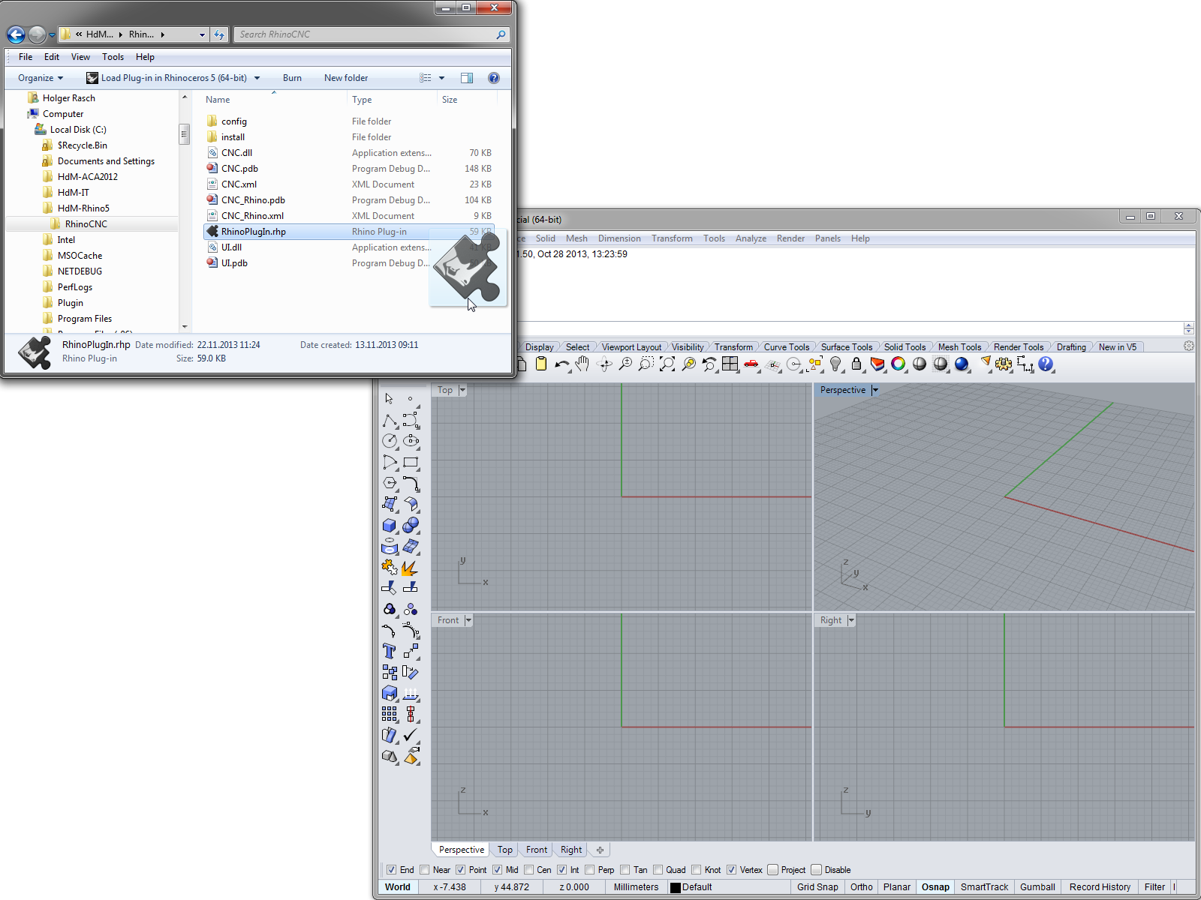
5. In Rhino5 type the command: CNC_OpenPanel
6. Make sure that you can see the whole plugin with all buttons.

If you cannot find the folder C:\HdM-Rhino5\RhinoCNC do the following:   
Open a Windows Explorer an go to: "W:\01 AUTOCAD\ACA2012\admin”.   
If you can’t see this folder, type the whole path in to the address bar.   
Double click on “Sync force - HdM-Rhino5.bat” and try this instruction again from point 1.

## Appendix C

for pin board next to the laser cutter and  
as part of the handout documentation after the cutter introduction

## LASER INSTRUCTIONS

### Safety Instructions and Security:

- Always stay at the machine while you are working! Never leave the room!

- For your own safety wear the special glasses if you want to see how the laser is working while cutting.

- It will protect you from reflecting rays.

- Whenever problems with the machine occur stop the machine. Push the emergency button and the machine will shut down.

- The number of the **Swiss Fire Department** is: **118**

- The fire extinguisher is next to the machine.   
Make sure that you know how to use in case there is a fire.

### Preparation on the machine:

#### 1. Switch on the machine

**Do NOT place your material on the table before you switch on the laser!**

With the wrong settings you will make the laser crash into your material! After switching on, the machine will take some seconds to initialize. Do not disturb while the laser is moving to the right hand corner. Let it run through its warm up exercise. When you are finished with the machine, turn it off with the key, located on the lower leg of the machine. Even if the laser is not cutting, it is still using energy.

#### 2. Place your material and move the laser over it, set the Laser Height, and then set the Reference Point.

#### Laser Height

You have to manually adjust the height of the laser to get a nice cut. If you were using the 5’’ lens, bring the laser down to the surface of your material until it touches. You can do so by screwing the metallic wheel on top of it. Check the marked position at the indicator attached to the laser and lift it up by 7 mm to make sure that the crossing point of the laser rays will exactly be on the surface of your material. If the laser is not set to this 7mm height, then the cutting beam will not cut perpendicular to the materials. This will not create straight, clean cuts. This is because the laser is not at its correct Focal Point, in relation to its lenses.

#### Reference Point

To set the reference point you have to select Tool 2 to be active. Tool 2 is a normal laser pointer with which you can set the reference point really precise. Therefore go into the menu, “**tool**”, “**select tool**”, “**tool** **number**” and “**2**” or push **2 1 1 2**.

Press the button on the machine with the two arrows going down and the red light of the laser pointer will be switched on. Set a new reference point by moving the laser to the position where you want it to be and push “**REF**”, then “**1**”.

After you set the reference point you have to select tool 1 to make sure that your file is going to be cut by the laser and not only be traced by the laser pointer. When you set the laser to be active again it will move to the position where you set your reference point before. It is always good to check the Reference point before cutting. In the “**REF**” option, press the command”**go to REF**”. If it is set correctly, it should to the cutting position.

#### Vacuum

To get a maximum of vacuum, cover the open parts of the table with the black rubber sheets. Fumes while cutting will then be better and more effective absorbed by the vacuum. If you are cutting particularly thin pieces, using a plastic or material which is **less** than **1.5mm**, use a masking tape to secure the material to the cutting grill. Thin materials have a tendency to warp or bend during cutting, and this should help counteract the movement.

#### Test Cut

A test cut is necessary in order to make sure that the laser is cutting through your material, because each material requires different settings.

Do test cuts by switching on the vacuum first! Go to “Vac” and press “enter”.

Push F1 and enter the speed for cutting form the table pinned on the wall corresponding to the material that you were using. The power should be always kept at 80%. You can check it by pressing F2.

In general it can be said: the slower the laser moves the deeper the cutting into your material will be.

After you did the test cut push “**online**” and then “**enter**”. While the laser is working you can stop your job any time by pushing “**STOP**”. To continue the cutting, push “**online**” again.

### Other Commands on the Laser Machine

#### F4: to clear the memory

If you want to cancel a running job, press “**STOP**”, than “**F4**” and “**enter**”. The memory of the machine will be cleared and you can send the new file. It is good to do this after cutting, as it leaves the machines memory clear for the next user.

#### F3: Re-plot

If you need to cut the same pieces again, place a new sheet of your material on the table and press the “**F3**” button. Your pieces will be cut the same way as they were cut before.

#### Adjusting the Vacuum Power

There is no real need to adjust the vacuum area as long as you use the rubber sheets to cover the open parts of the table. Push “**VAC**” then “**3**”. You change the size with the right and left buttons. When you have the correct size, press “**enter**”. Other options for changing the vacuum can be found on the vacuum tubes, leading off the machine to the extraction cans or on the laser itself. On the laser, simply removing the magnetic strip will reduce the power of the suction. If this is still too strong, the nozzles at the base of the machine can be twisted open, reducing the power further. It is important to close these after cutting, as the gases produced by the laser will not fully be absorbed into the extractors. Please check this before leaving, as ventilation in the cutting room is poor.

#### Cutting Small Pieces

If you were cutting small pieces it can be that the vacuum above the laser is too powerful, trying to soak in your pieces. Open the white protection cap on the laser by rotating it to the side to decrease the power of the vacuum. If it is really necessary, the small pieces can be retrieved from the extractor cans, as they will not pass through the filters. It is not recommended to do this, as it is very toxic. Spacing the pieces you want to cut out across the material can help this… but is mainly learned through experience.

When finished, it is very important to clean the cutting surface of the machine. Small pieces have a tendency to be moved by the vacuum, and can end up in the belt drive of the machine (this is the part that moves the laser along the x-axis). These small pieces leave marks on the metal belt, and damage the movement of the machine. Any unusual sounds should be reported to the Trainees responsible for the machine, or to the Workshop.

#### After cutting, switch off the machine

We have a service check for the laser after 2000 hours of cutting, on average 4 times a year. So whenever you finished please switch the machine off in order extend the guarantee. This can be done by turning the key off on the base off the machine. A mechanic will spend usually 4 hours de-assembling the machine, and running checks on all the major parts. You will be notified beforehand about these checks. The machine will obviously not be used during this procedure.

#### Filters for Cutting Cardboard and Wood

The Machine is cleaned and maintained 3 times a week (Monday – Wednesday – Friday).

The Filters for cutting Plexi are also changed at these times: Consisting of 2 Thick Matts, and 1 Thin Matt, in each of the Filter Cans. The machine is always prepared for cutting Plexi. The Filters can be located in the cupboard left of the cutter in the basement.

Cutting special materials (Wood, Card etc.) requires new filters to be inserted. In order to do this, the Filters must be changed behind the Laser Machine. (In the two steel cans with the pipes sticking out)

The new Filters are located in the room to the RIGHT of the laser, OPPOSITE the Milling Machine.

Simply open the can and place 1 new filter ON TOP of the existing ones, for BOTH filter cans, then make sure the cans are securely shut at the locks.

When you are finished cutting with the machine, please REMOVE the Filters, and place them in a black garbage bag (located opposite the laser), then into a container. Not removing the Filters can damage the machine, as they are absorbing the smoke produced from the cutting. Please wear a mask and rubber gloves when doing this, as the gases can be poisonous inside the Filter cans

Operational Hours of the Laser Machine

The machine is opened from around 9:30 in the morning to 18:00 in the evening during normal working days. Cleaning of the Machine takes place on Monday, Wednesday and Friday, between 09:00 – 09:30 in the morning.

There is NO laser working on the weekend!

#### Special Circumstances

Sometimes the laser is required over the weekend for project deadlines.

In this Instance, Contact the Workshop. They will provide you with a document that explains the procedure.

#### **In General**

Take good care of the machine and always take away your trash after cutting!!!

Be aware that if you were not following up the rules you will be kicked out immediately!

If you have any questions, do not hesitate to contact (Trainees) Richard Leung, Sandra Sarkunaite, (Workshop) Günther Schwob or (DT) Kai Strehlke.

## APPENDIX D

For DT and if necessary IT use only

## Preparation for the control computer

A control computer is a computer with the ability so send cut commands directly via serial COM port to a cutter. Without the following steps the plugin cannot send job to the device, only plt file creation is possibly.

The following instruction is only for the control computers which are directly connected to the cutter devices!

Every control computer has to be defined in the hdm.workshp.xml file. Read the chapter about the workshop xml. Important is the controller entity:

<controller pair="M1200@BSL-DE35-1062" connnection="Serialport 1"/>

M1200 is an ID from a device.xml and BSL-DE1062 the computer name of the control computer.  
“Serialport 1” is the ID for the connection also defined in the workshop.xml file.

You can find your computer name by pressing + Pause

The following both operation must execute with local administration rights:

In “C:\HdM-Rhino5\RhinoCNC\install” you find a shortcut to start rhino together with the CNC_OpenPanel command. You must replace the two local shortcuts under: “C:\ProgramData\Microsoft\Windows\Start Menu\Programs\Rhinoceros 5” and “C:\Users\Public\Desktop”.

Additionally is it necessary to import the “C:\HdM-Rhino5\RhinoCNC\install\Plugin_Install.reg” to the registry. These registry settings will be register the plugin so that he install it for every user automatically and will also call CNC_OpenPanel if a user double clicks on a rhino file.

## XML Documentation

All parameters for the Plug-In are defined in a bunch of XML-files. They are located in the config folder at the same location as the RhinoPlugIn.rhp file. There are three different kinds of files. The filename is delimited in three parts. At first a simple description followed by a point, one of the three types (workshop, device and material) and at last the file extension xml. For a proper work we need at least one of each type.

After finalizing our plugin had these files:

hdm.workshop.xml − main description

zund.device.xml − description for the Zünd cutter

laser.device.xml − description for the Laser cutter

cardboard.material.xml − description for the cardboard material

foamboard.material.xml − description for the foamboard material

plexi.material.xml − description for the plexi material

### *.workshop.xml

The workshop-file contains all global information about our “workshop”. This is currently a list of all control-computers and how they are connected to the cutter device. And also stored here are the definitions for the communication setting. Additionally the command to switch a cutter online is also stored here. It can only exist one .workshop.xml file, like: hdm.workshop.xml

Example for a minimal workshop.xml file:

<?xml version="1.0" encoding="utf-8" ?>

<workshop DefaultDevice="M1200">

<connector type="serial" id="Serialport 1" port="COM1" speed="19200" parity="0" databits="8" stopbits="1" handshake="2" readtimeout="500" writetimeout="2000"/>

<controller pair="M1200@BSL-DE35-1062" connnection="Serialport 1"/>

</workshop>

Root entity: workshop single mandatory attribute: DefaultDevice

The DefaultDevice is an ID defined from a device.xml file and descripts the device which will be used, if no precisely statements will follow.

Example: <workshop DefaultDevice="M1200">

Sub entities: connector, controller

The connector entity descripts a kind of connection. Currently only serial connections are supported. The following attributes are mandatory:

type currently only “serial” is allowed

id a unique ID for this entity

port the Portname of the used communication port, like COM1

speed serial baud rate

parity parity 0 = none 1 = odd 2 = even 3 = mark 4 = space

databits length of data bits per byte

stopbits 0=none 1 = one 2 = two 3 = OnePointFive

handshake 0=none 1 = XOnXOff 2 = RequestToSend 3 = RequestToSendXOnXOff

readtimeout timeout in millisecond

writetimeout timeout in millisecond

Example: <connector type="serial" id="Serialport 1" port="COM1" speed="19200" parity="0" databits="8" stopbits="1" handshake="2" readtimeout="500" writetimeout="2000"/>

The controller entity descripts a computer how’s controlling the cutter device. The following attributes are necessary:

pair a pair indicates which computer belongs to which device in the form DeviceID@Computername

connnection an ID of a valid connector (see above)

Example: <controller pair="M1200@BSL-DE35-1062" connnection="Serialport 1"/>

### *.device.xml

The device-file is the core description file. For each cutter we need one file. The file stores information about size, graphical representation inside Rhino and HPGL command phrases. Every tool of a cutter has here his description.

It can exist as much device.xml files as needed. Currently at HdM we have two of them. Per file is only one device entity allowed.

Example for a minimal device-file with just one tool:

<?xml version="1.0" encoding="utf-8" ?>

<device id="EX2000" text="Example Device 2000">

<property id="factor" value="100"/>

<property id="workzone" x="2000" y="2000"/>

<property id="BoundingTool" text="TOOL"/>

<property id="BBoxOffset" value="5"/>

<property id="TresholdNonOptimization" value="10000"/>

<property id="TresholdNearestNeighbourOptimization" value="1200"/>

<property id="ToolOrder" text="TOOL"/>

<property id="prejob" text="PU;PA;PB2,1;SD300;AS2,4;RS0,0,0;"/>

<property id="postjob" text="JB0;XX12,2;MSDone by {username};NR;"/>

<property id="SwitchOnline" text="ZF5;"/>

<conduit id="absolute">

<line x1="0" y1="0" x2="1200" y2="0"/>

<line x1="2000" y1="0" x2="1200" y2="2000"/>

<line x1="2000" y1="2000" x2="0" y2="2000"/>

<line x1="0" y1="2000" x2="0" y2="0"/>

</conduit>

<tool id="TOOL">

<property id="speeddown" value="20" min="0.1" max="100" text="Speed Down [mm/s]" displayfactor="10" ishidden="false"/>

<property id="pretool" text="XX12,2;MSTool:{id};{id};ZP2000,0;VS{speeddown},100;CR2.0;"/>

<property id="posttool" text="PU;"/>

</tool>

</device>

Root entity: device mandatory attributes: id, text

id it’s a unique name for the device, this id will be used several times in the xml-file and the plug-in too to identify this device

text this is a free text which will be used in the graphic user interface instead of the id because it is more readable

Example: <device id="M1200" text="Zünd MS - 1200">

Allowed sub entities: property, conduit, tool

The property entity means a common property. In the device.xml it will used for a lot of different things:

id the ID for the property

value a Value (Double)

x a X coordinate value (Double)

y a Y coordinate value (Double)

text a text (String)

min a minimal allowed value for this property. If the value attribute is smaller than min, the value will set to min (Double).

max a maximum allowed value for this property. If the value attribute is bigger than max, the value will set to max (Double).

ishidden decide that a value will be shown in the GUI (and will be changeable). This works only in sub entities of the tool element (Boolean).

displayfactor the factor for the value to show in the GUI (Double)

Example: <property id="speeddown" value="20" min="0.1" max="100" text="Speed Down mm/s]" displayfactor="10" ishidden="false"/>

In a device.xml file, the following ids will be allowed inside of the property entities:

factor between mm und den device units (Cutter) (value)

workzone the size of the cutting area in mm (x, y)

BoundingTool the ID of the default tool to cut a bounding box, it can be overridden by a material definition. (text)

BBoxoffset offset of the bounding box from the geometry in mm. (value)

TresholdNonOptimization  
value from which number of objects no path optimization will performed (integer)

TresholdNearestNeighbourOptimization   
value from which number of objects only the nearest neighbor heuristic will performed (integer)

ToolOrder comma separated list of tool ids in order to cut (text)

delay time in millisecond that will be wait before the job will start, this is only effective if the prejob is using this, it will also use by the calculation for the time forecast (integer)

prejob a chain of HPGL command which will send at the beginning of a job (text)

postjob a chain of HPGL command which will send at the end of a job (text)  
**For a proper work is it very important that the** postjob **contains the** JB0; **and the** NR; **command.**

SwitchOnline command to switch the device online if its send as front-end command

**IMPORTANT**: prejob, postjob, pretool and posttool has the capability to exchange values in curly brackets with values defined outside of the property. Actually this property was designed to send a HPGL command phrase before or after geometry based sequences. But these phrases must contain values controlled and defined by the user via the plugin interface. Therefore we can define properties which will be read by the plugin and after that they can be manipulate within the plugin. These manipulated values will be used to generate the output phrase. Value in curly brackets will be interpreted as id from a property and will replaced with his value.

Example:   
<property id="prejob" text="PU;PA;SD{delay};RS0,0,0;"/> will be produced with the 300 from the <property id="delay" value="300"/>. this: "PU;PA;SD300;RS0,0,0;"   
  
The placeholder {username} is not defined in an xml-file, he will replace with the current username.

Example:  
<property id="postjob" text="JB0;XX12,2;MSDone by {username};NR;"/> ;"/> will be produced with the current logged in username, this: "JB0;XX12,2;MSDone by h.rasch;NR;"

The conduit entity descripts the graphical representation for the device inside of the Rhino workspace. Is has just one attribute (id) and even just one kind of sub entity:

line it’s a definition of a line from X1, Y1 to X2, Y2. unit is millimeter (double)

Sub entity: tool, mandatory attribute id descripts a tool

The following properties have these ids:

speedup speed for the lifted tool in cm per second (double)

speeddown speed for the lowered tool in cm per second (double)

for Zünd only:

zposup Up-position for the tool in device units (double) (see factor) not for SP4

zposdown Down-position for the tool in device units (double) (see factor) not for SP4

for laser only

powerwork laser power while cut (percent, double)

powermin laser power while pen up (percent, double)

powerrecess laser power during the 'tool down after waiting time' (percent, double)

interuptiontime time between two cuts, this value is needed by time calculation (milliseconds, integer)

pretool a chain of HPGL command which will send at the beginning of a tool.  
**For a proper work is it very important that the** pretool **contains the** XX12,2;MSTool:{id}; **command string.**

posttool a chain of HPGL command which will send at the end of a job.

Example:

…

<property id="delay" value="300" />

<property id="downacceleration" value="2" />

<property id="upacceleration" value="4" />

…

<property id="prejob" text="PU;PA;PB2,1;SD{delay};AS{downacceleration},{upacceleration};RS0,0,0;"/>

…  
  
The final output will be:

PU;PA;PB2,1;SD300;AS2,4;RS0,0,0;

### *.material.xml

In a material-file we define names and tool settings for different materials. Every material that we define needs a unique ID. All settings with the same ID will be collected as same material. It is only necessary to define tool settings which differ from settings defined in the device files. It is not necessary to differ in the material definition between different devices. Only tool related settings are possible.

It can exist as much material.xml files as needed. It’s a good idea to create for each kind of material a separate file, but this is not mandatory.

Example for a simple material:

<materials>

<material id="foamboard_3mm" display="Foamboard 3 mm">

<toolsettings id="TOOL" speeddown="50"/>

</material>

</materials>

Root entity: materials, no attributes

Sub entity material mandatory attributes: id, display optional attribute: BoundBoxTool

id unique id of the material, it has to be unique for all material.xml files

display name of the material how it will displayed in the Plug-In

BoundBoxTool id of the tool (see *.device.xml) to cut the bounding box.

Sub entity toolsettings mandatory attribute: id

id ID of the tool which we override a value

The following attributes are allowed. The values will override the definition in the device.xml

speedup, speeddown, zposup, zposdown, pretool, posttool, powerwork, powermin, powerrecess, interuptiontime

## Defaults Settings

plexiglass / acrylic @ 7mm distance

|  |  |  |  |
| --- | --- | --- | --- |
| thickness  [mm] | modus | speed [mm/s] | power [%] |
| 0.6 | cutting  engraving | 300  100 | 80  8 |
| 1.0 | cutting  engraving | 190  100 | 80  8 |
| 1.5 | cutting  engraving | 100  100 | 80  8 |
| 2.0 | cutting  engraving | 60  100 | 80  8 |
| 3.0 | cutting  engraving | 40  100 | 80  8 |
| 4.0 | cutting  engraving | 25  100 | 80  8 |
| 5.0 | cutting  engraving | 20  100 | 80  8 |
| 6.0 | cutting  engraving | 15  100 | 80  8 |
| 7.5 | cutting  engraving | 10  100 | 80  8 |
| 8.0 | cutting  engraving | 10  100 | 80  8 |
|  | cutting  engraving |  |  |
|  | cutting  engraving |  |  |
|  | cutting  engraving |  |  |
|  | cutting  engraving |  |  |
|  | cutting  engraving |  |  |
|  | cutting  engraving |  |  |
|  | cutting  engraving |  |  |

**PLEASE REMOVE FOIL**

**&**

**CLEAN AFTER YOURSELVES**